**Intelligent Healthcare Assistant Using IBM Granite**

**1. INTRODUCTION**

* 1. **Project Overview**

The Intelligent Healthcare Assistant is a modular AI-powered system designed to transform healthcare services through intelligent automation, decision support, and personalised care. Built using IBM Watsonx’s Granite LLM, FastAPI, and Streamline, it integrates health data analysis, symptom assessment, medical record summarisation , and anomaly detection—delivered through a user-friendly dashboard.

**1.2 Purpose**

To empower doctors, healthcare workers, and patients by providing real-time health insights, summarising medical documents, and improving clinical efficiency through structured and unstructured data analysis.

**2. IDEATION PHASE**

**2.1 Problem Statement**

Modern healthcare systems lack a centralised AI solution that can streamline patient interaction, automate clinical workflows, and assist in decision-making with interpretability and personalisation.

**2.2 Empathy Map Canvas**

Think & Feel: Doctors feel overwhelmed with patient data; patients desire clear understanding of their conditions.

See: Disconnected EMRs, lengthy reports, unoptimised diagnostics.

Hear: Complaints about wait times, miscommunication, or lack of personalised care.

Say & Do: Patients search symptoms online; doctors seek decision support tools.

Pain: Time-consuming paperwork, data overload, low diagnostic support.

Gain: A single intelligent assistant that can summarise, analyse, and offer health recommendations.

**2.3 Brainstorming**

Use LLMs for summarising medical records and prescriptions

Integrate symptom checkers and medical chat assistant

Enable predictive analysis for early diagnosis

Use anomaly detection for critical health alerts

Build dashboards for healthcare workers and administrators

**3. REQUIREMENT ANALYSIS**

**3.1 Solution Requirements**

Secure backend with FastAPI

Interactive health dashboard (Stream-lit)

Integration with medical databases and APIs

Use of IBM Watsonx’s Granite LLM for intelligent tasks

HIPAA-compliant data handling

**3.2 Data Flow Diagram**

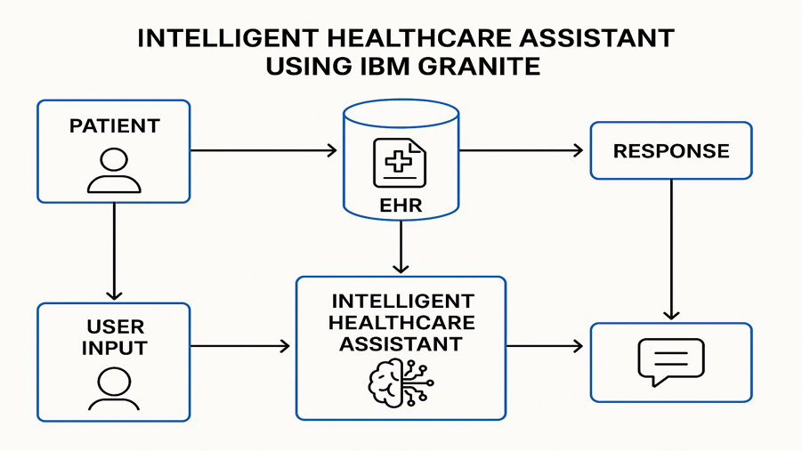

**3.3 Technology Stack**

IBM Watsonx’s Granite LLM

Pinecone (for medical document semantic search)

FastAPI, Stream-lit

Python (Pandas, Sci-fi T-learn, dotting, pedantic)

Sentence-transformers, Mat plot lib

**4. PROJECT DESIGN**

**4.1 Problem-Solution Fit**

Bridges the gap between complex health data and patient/doctor understanding by offering real-time, intelligent assistance and insights.

**4.2 Proposed Solution**

An AI assistant that supports medical summarisation, anomaly alerts, health predictions, and chatbot-based interaction—all accessible via an intuitive dashboard.

**4.3 Solution Architecture**

Backend → FastAPI routers

Embedding Engine → Pinecone + Sentence Transformers

LLM Services → IBM Granite LLM

Frontend → Stream-lit-based dashboard with tabbed navigation

**5. PROJECT PLANNING & SCHEDULING**

**5.1 Project Phases**

Environment Setup

LLM Integration & API Key Management

Modular API Development for Healthcare Use Cases

Stream-lit Dashboard UI Creation

Embedding + Semantic Search for Medical Docs

Predictive Analysis + Anomaly Detection

Health Report Generation + Medical Chat Assistant

Final Integration & Testing

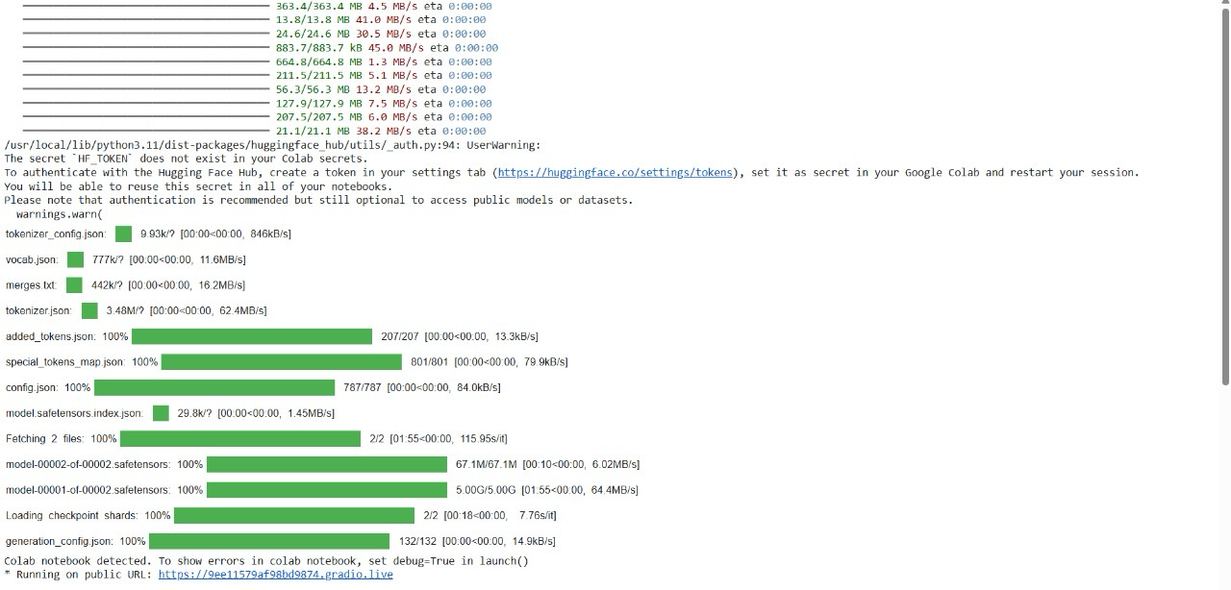.

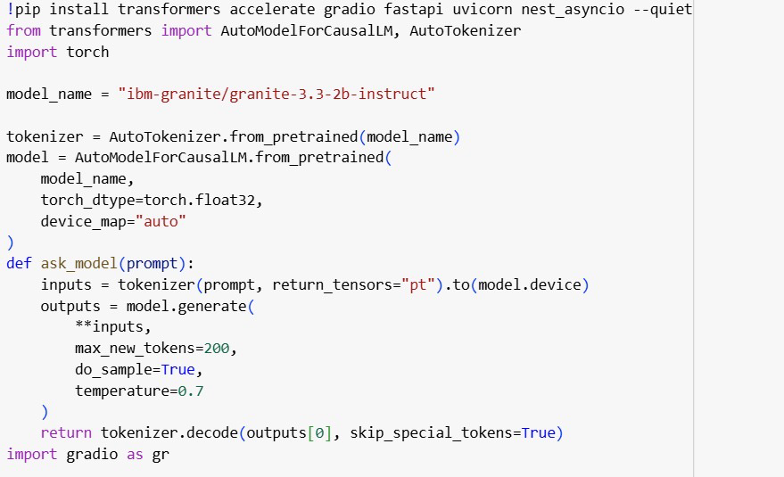

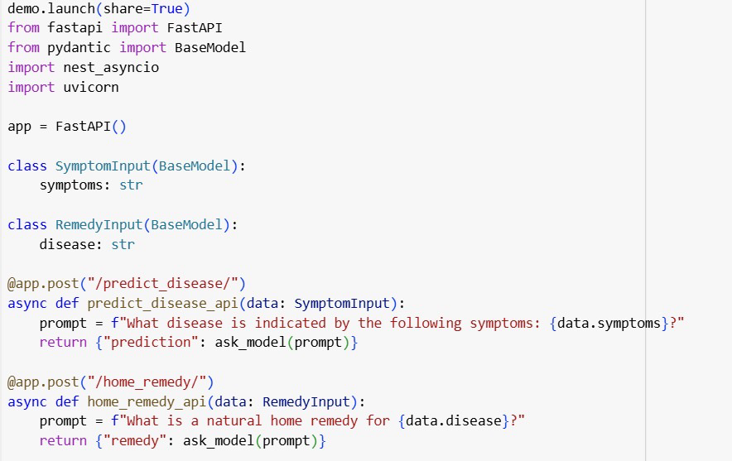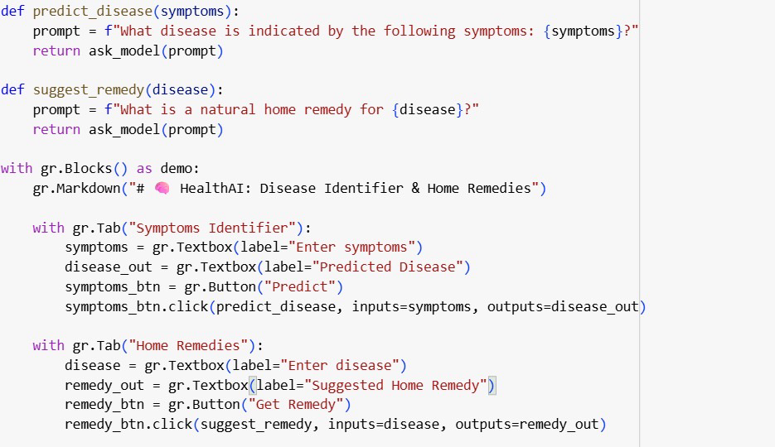



**6. FUNCTIONAL AND PERFORMANCE TESTING**

**6.1 Performance Testing**

All endpoints validated with Swagger UI

Load-tested patient data processing and anomaly detection

Assessed performance of summarisation under large record loads

**7. RESULTS**

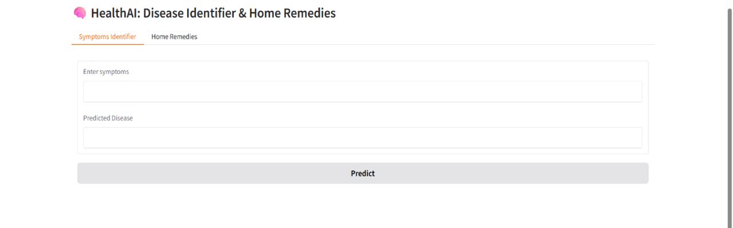**7.1 Output Screenshots**

**8. ADVANTAGES & DISADVANTAGES**

**Advantages**

Modular and scalable healthcare solution

Patient- and clinician-focused design

Real-time alerts and predictive diagnostics

Leverages IBM Granite for medical summarisation and guidance

**Disadvantages**

Requires secure handling of sensitive health data

Dependency on internet and API services

Regulatory compliance complexity (HIPAA, etc.)

**9. CONCLUSION**

The Intelligent Healthcare Assistant proves how AI can revolutionise healthcare by delivering smarter decision-making, efficient workflows, and personalised care. With IBM Granite at its core, it offers transparency, speed, and accuracy across clinical tasks.

**10. FUTURE SCOPE**

Integration with wearables and IoT-based health sensors

Voice-enabled interaction for accessibility

Multilingual medical assistance

Deployment in hospital systems and telemedicine platforms

**11. APPENDIX**

**GitHub Repository**: https://github.com/syamala77l.

**HealthAl-Intelligent-Healthcare-Assistant-Using-IBM-Granite**

**Project link :** https://6d54bca1443e1d6f7c.gradio.live/